# Azure Major Project 02

* Create two Resource groups by Name (rg001) and (rg002).
* Create two virtual networks (vnet01) and (vnet02) in the above created resource groups respectively.
* Create two Storage Accounts and only exposed these storage accounts to the above created VNets only.
* Create two users (user01 and user02) in Azure Active Directory.
* Check whether you are able to login with any of the one newly created user.
* Give above user's access to the storage account with the Contributor role.
* Create an Azure Policy to only allow certain locations (Southeast Asia) for the resource group, try to create a resource in any other location and check the policy evaluation. (You can use any other region).
* Setup Ingress and Egress metrics for the both the above created Storage Account.
* Create Action (Verzactgrp) Group for the above alert with your email id.
* Check if you are receiving the alert.

Output - Create a Word Document and attach all the screenshots of the above activity along with one liner description

* Resource group:

A Resource group is simply a logical construct that groups multiple resources together so they can be managed as a single entity based on lifecycle and security.

* Resource groups by Name (rg001) and (rg002) is created.

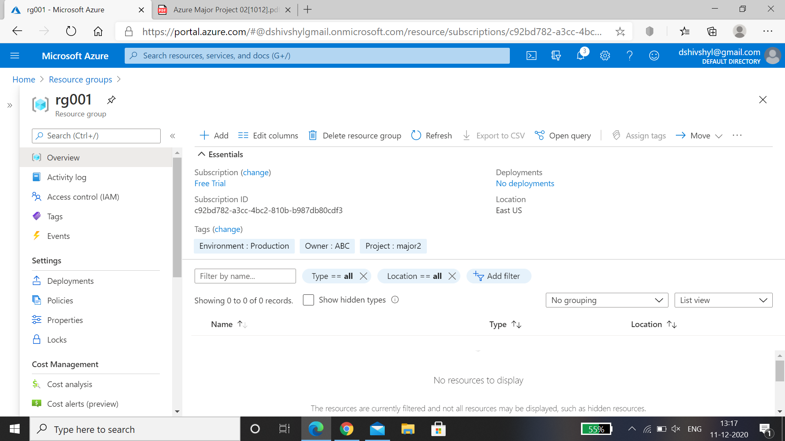

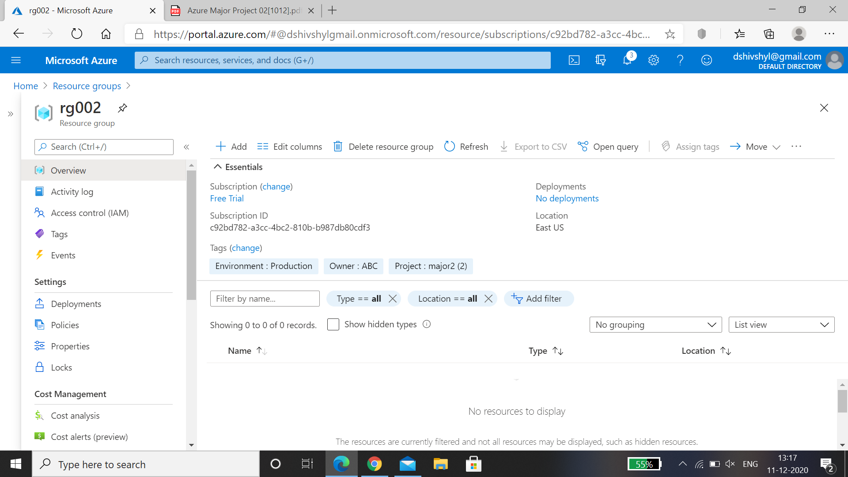

* Virtual Machine:

A virtual machine is an emulated computer system created using software. It uses physical system resources, such as the CPU, RAM, and disk storage, but is isolated from other software on the computer.

* Created two virtual networks (vnet01) and (vnet02) in the above created resource groups respectively.

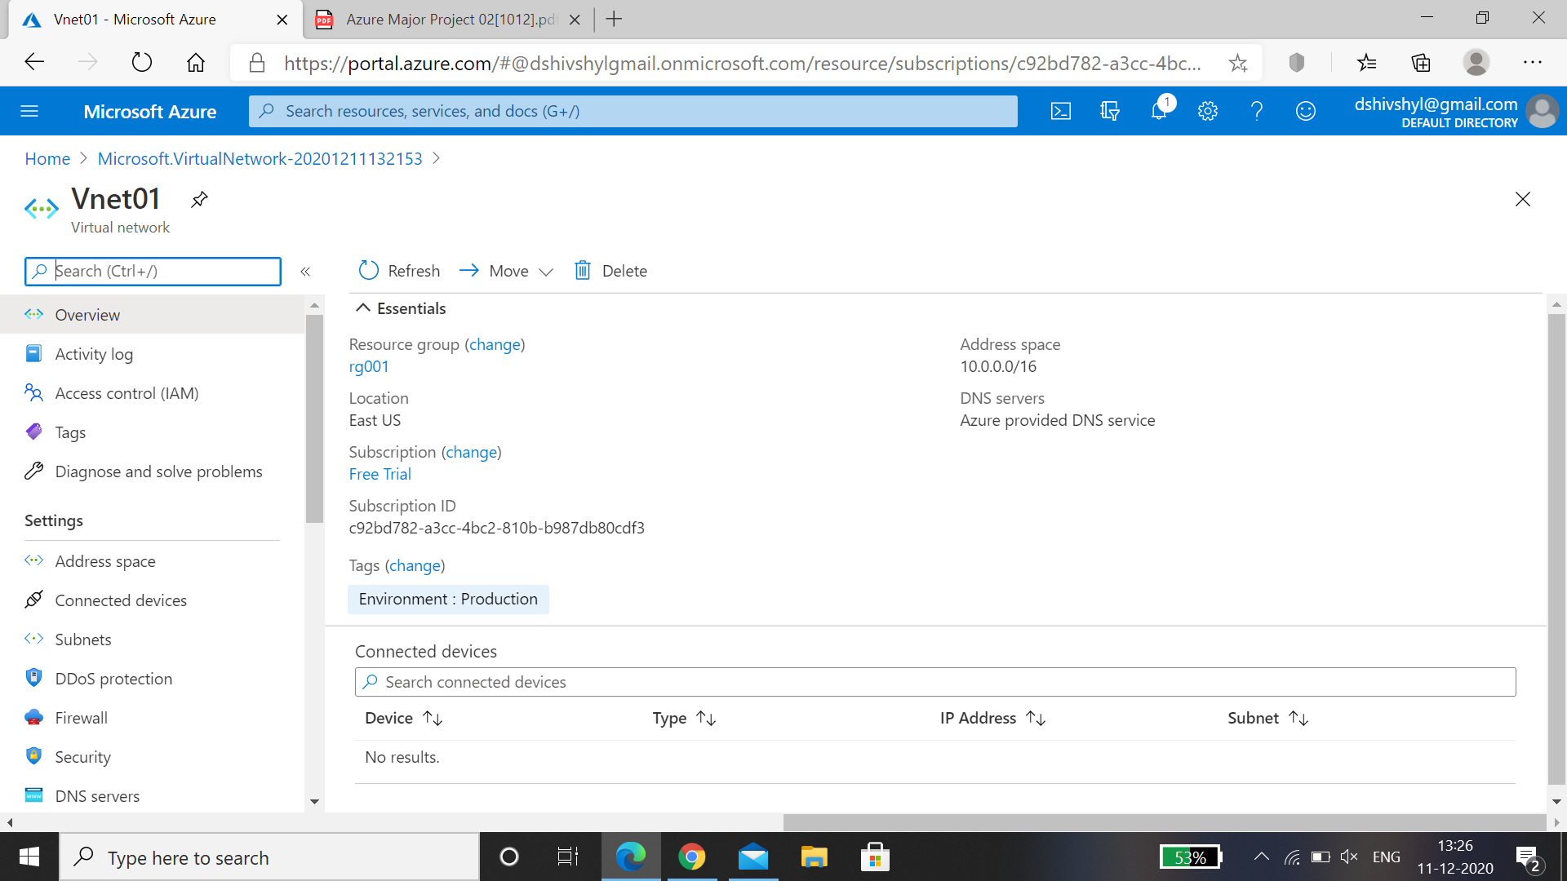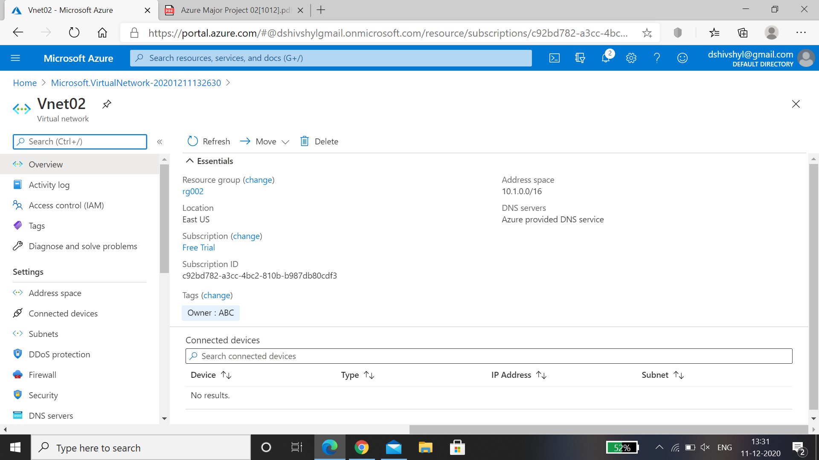

* Created two Storage Accounts and only exposed this to the created VNets.

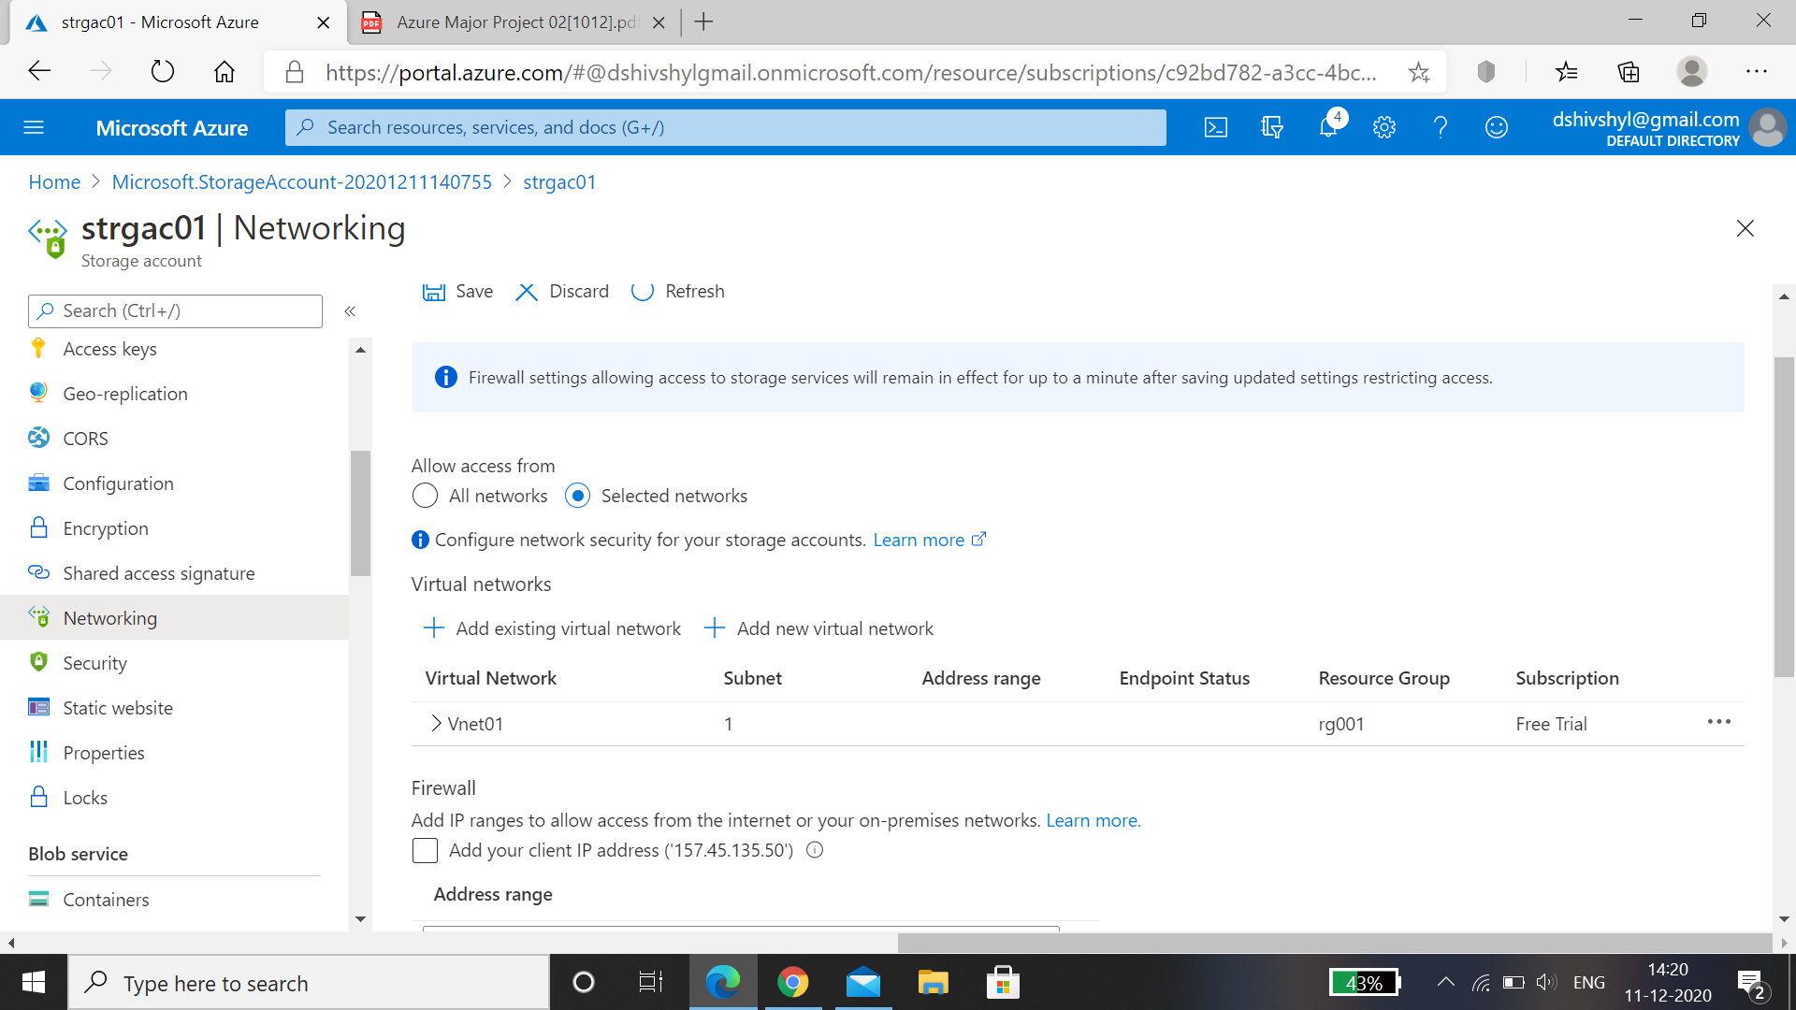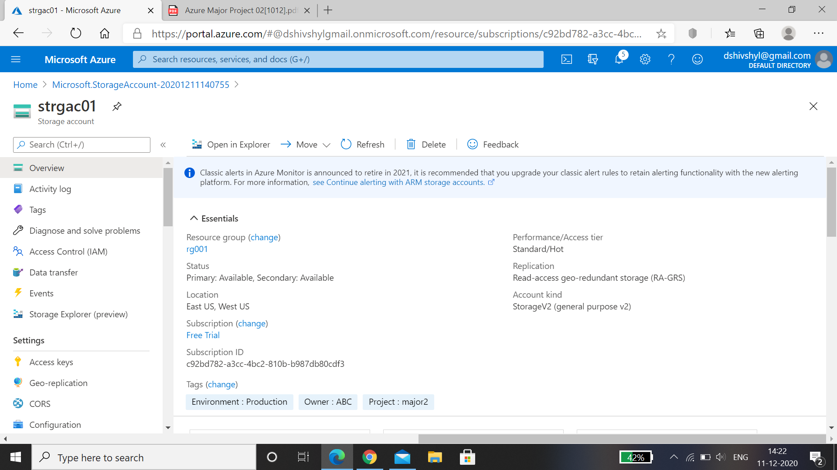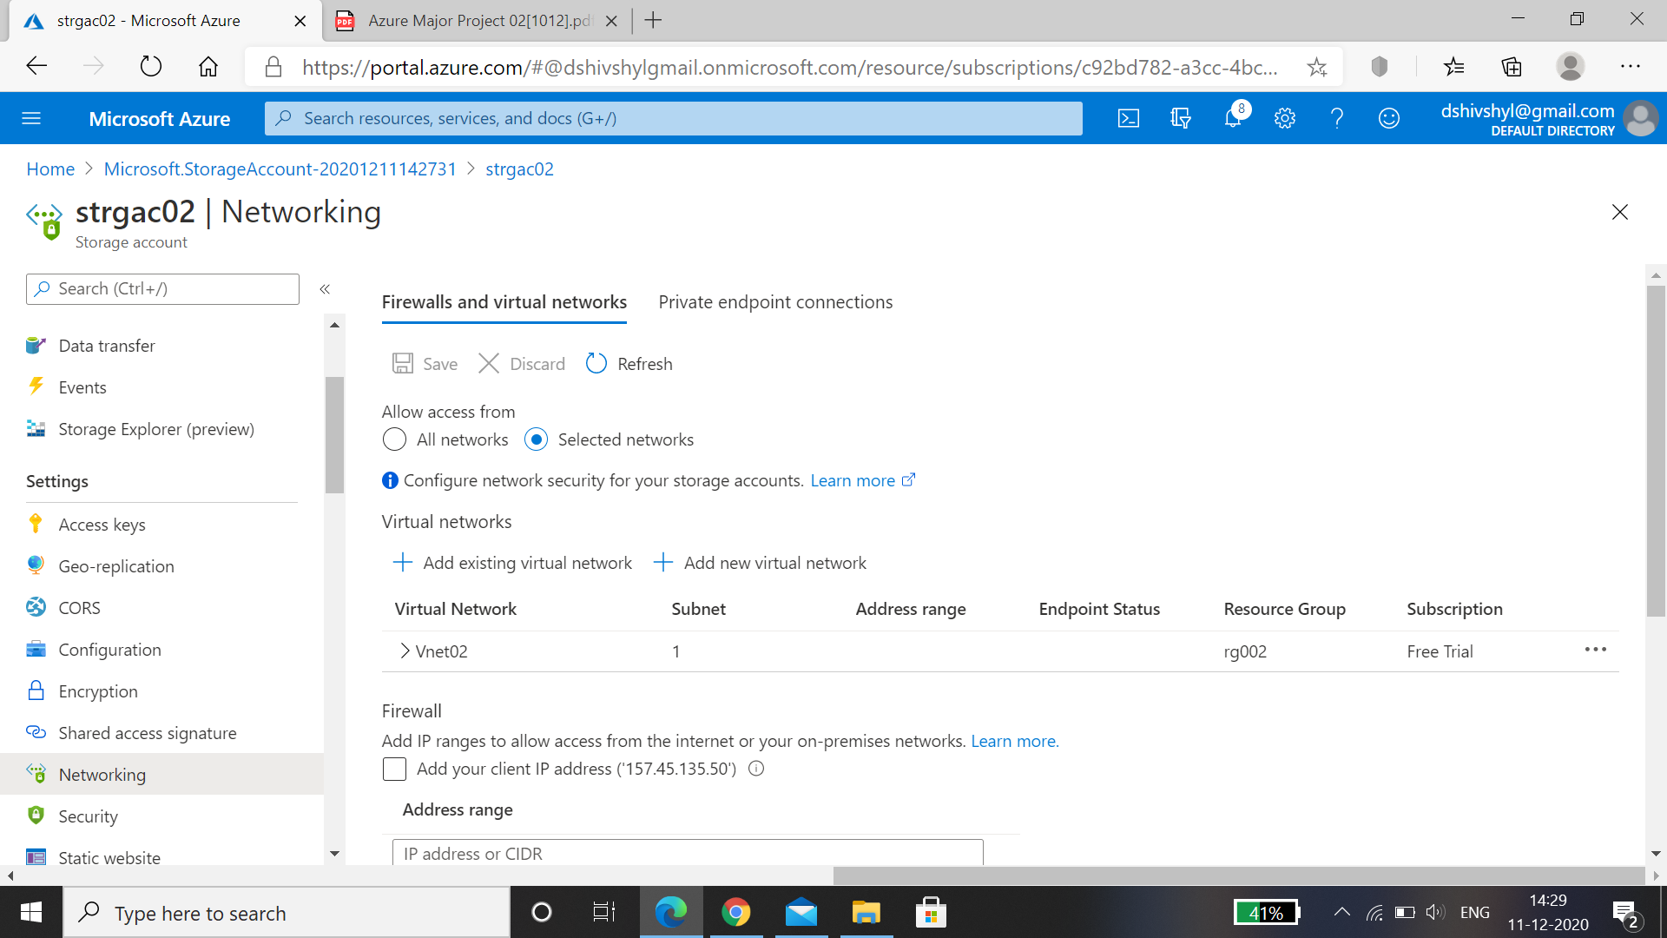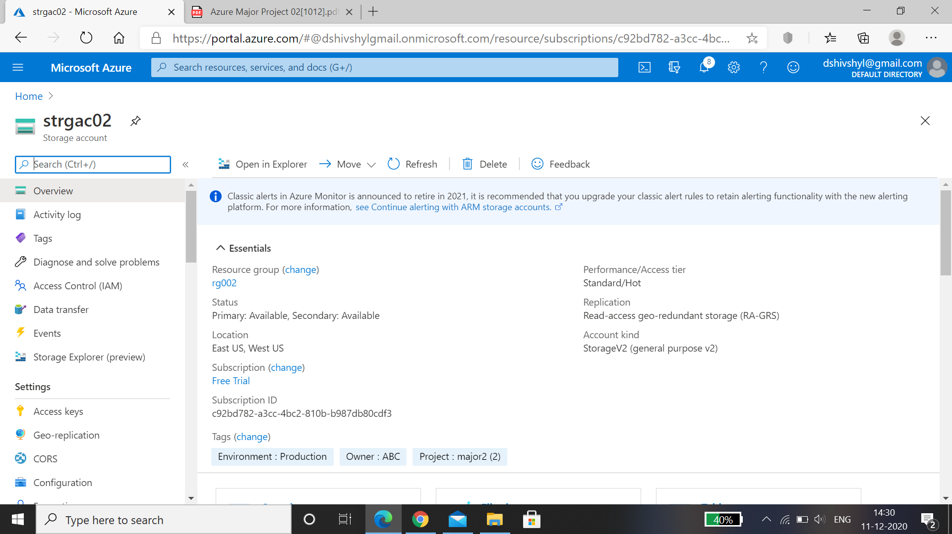

* Two users (user01 and user02) are created in Azure Active Directory.

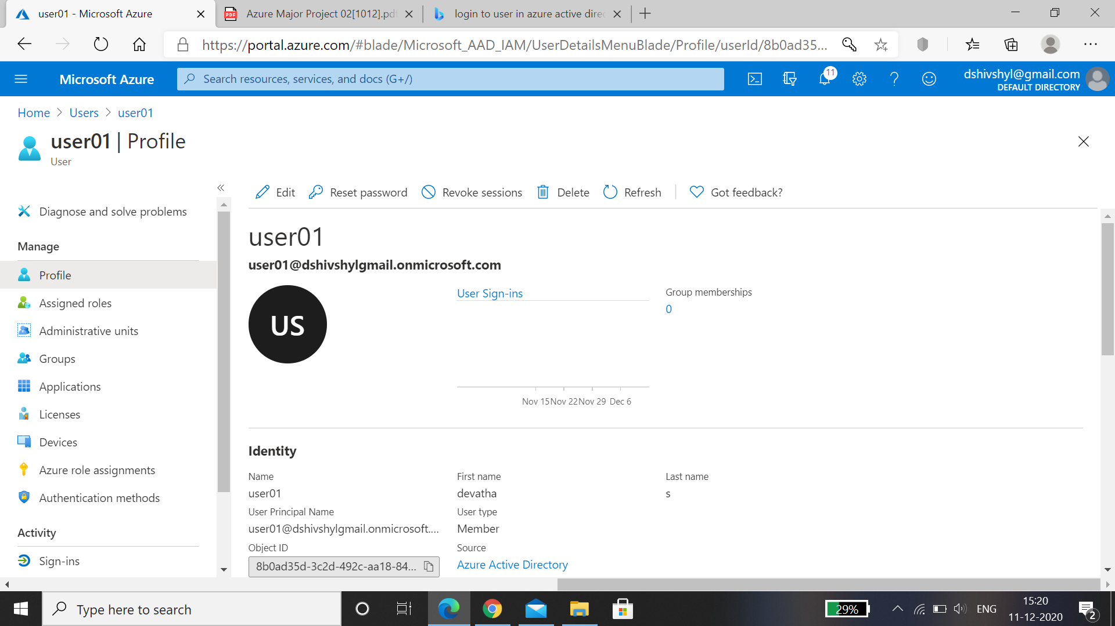

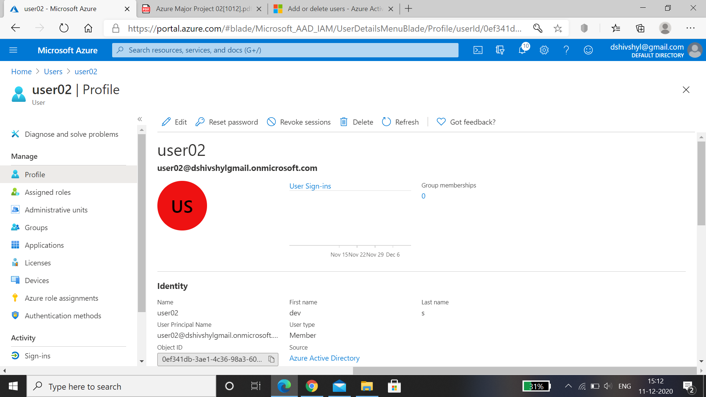

* we are able to login with user02.

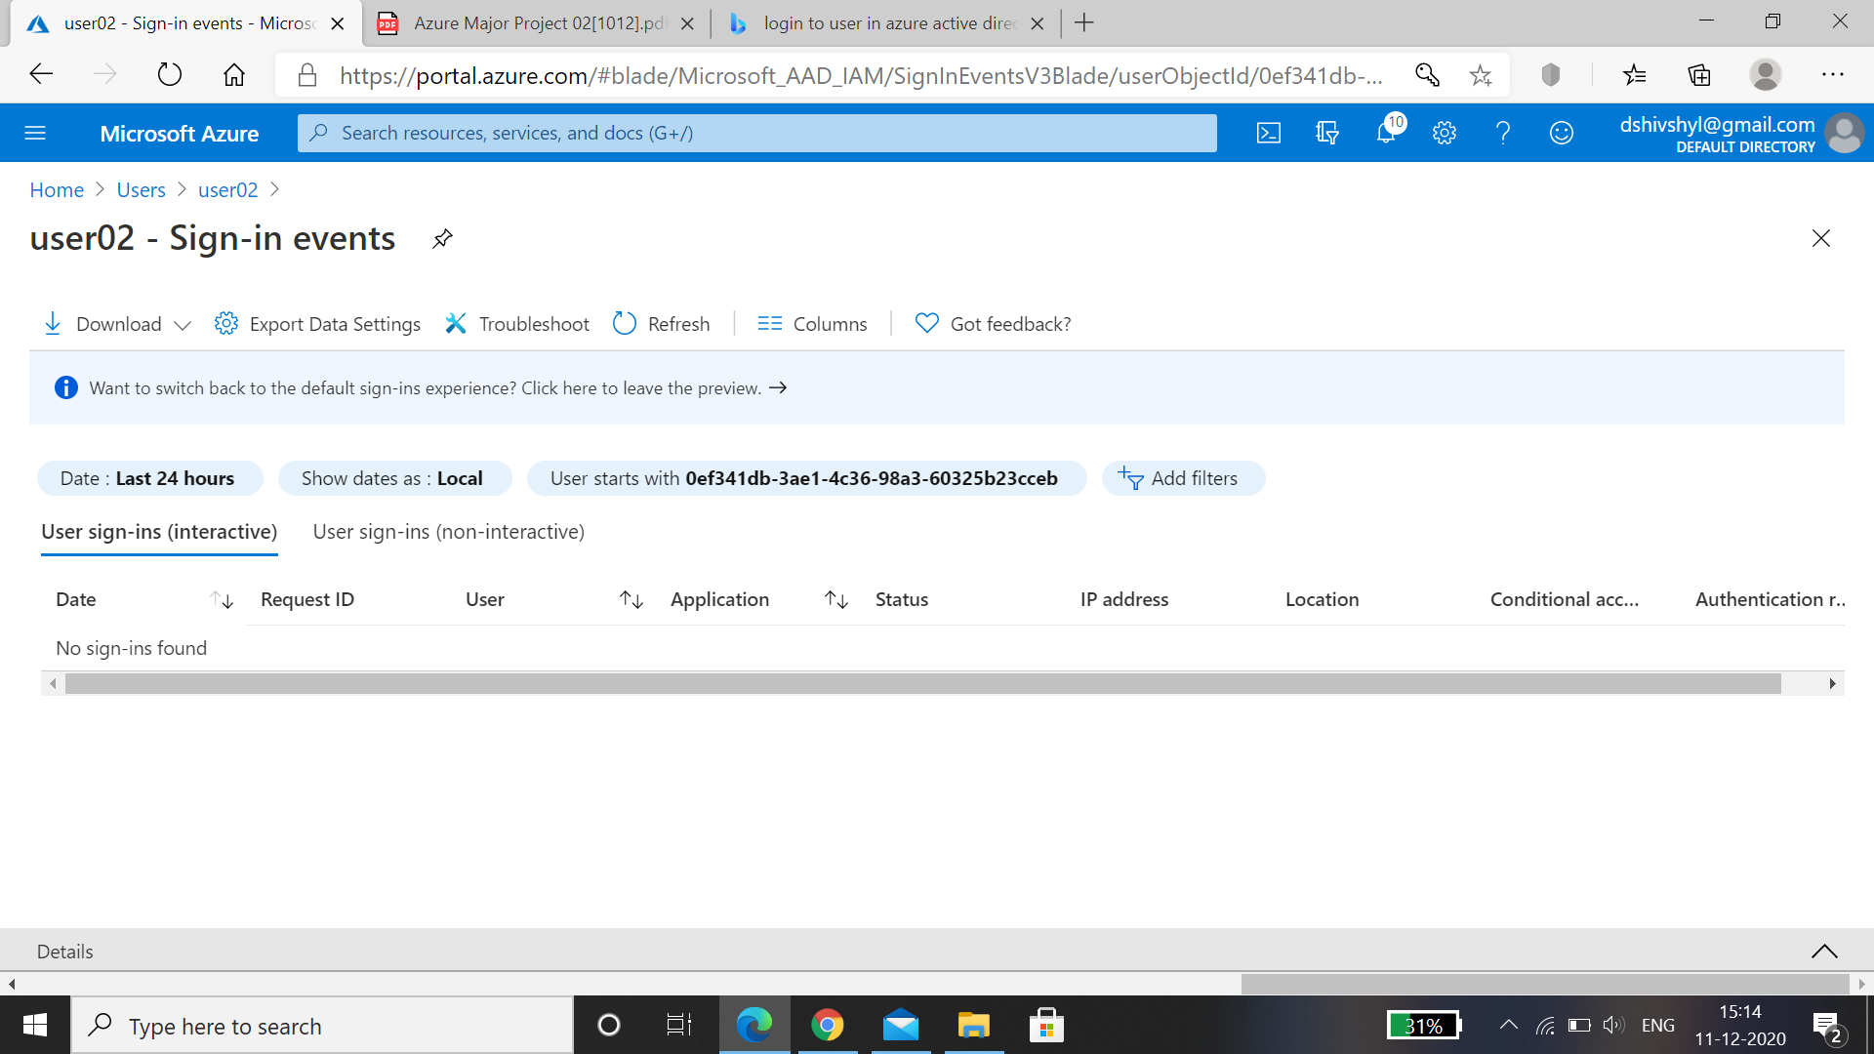

* Give above user's access to the storage account with the Contributor role.

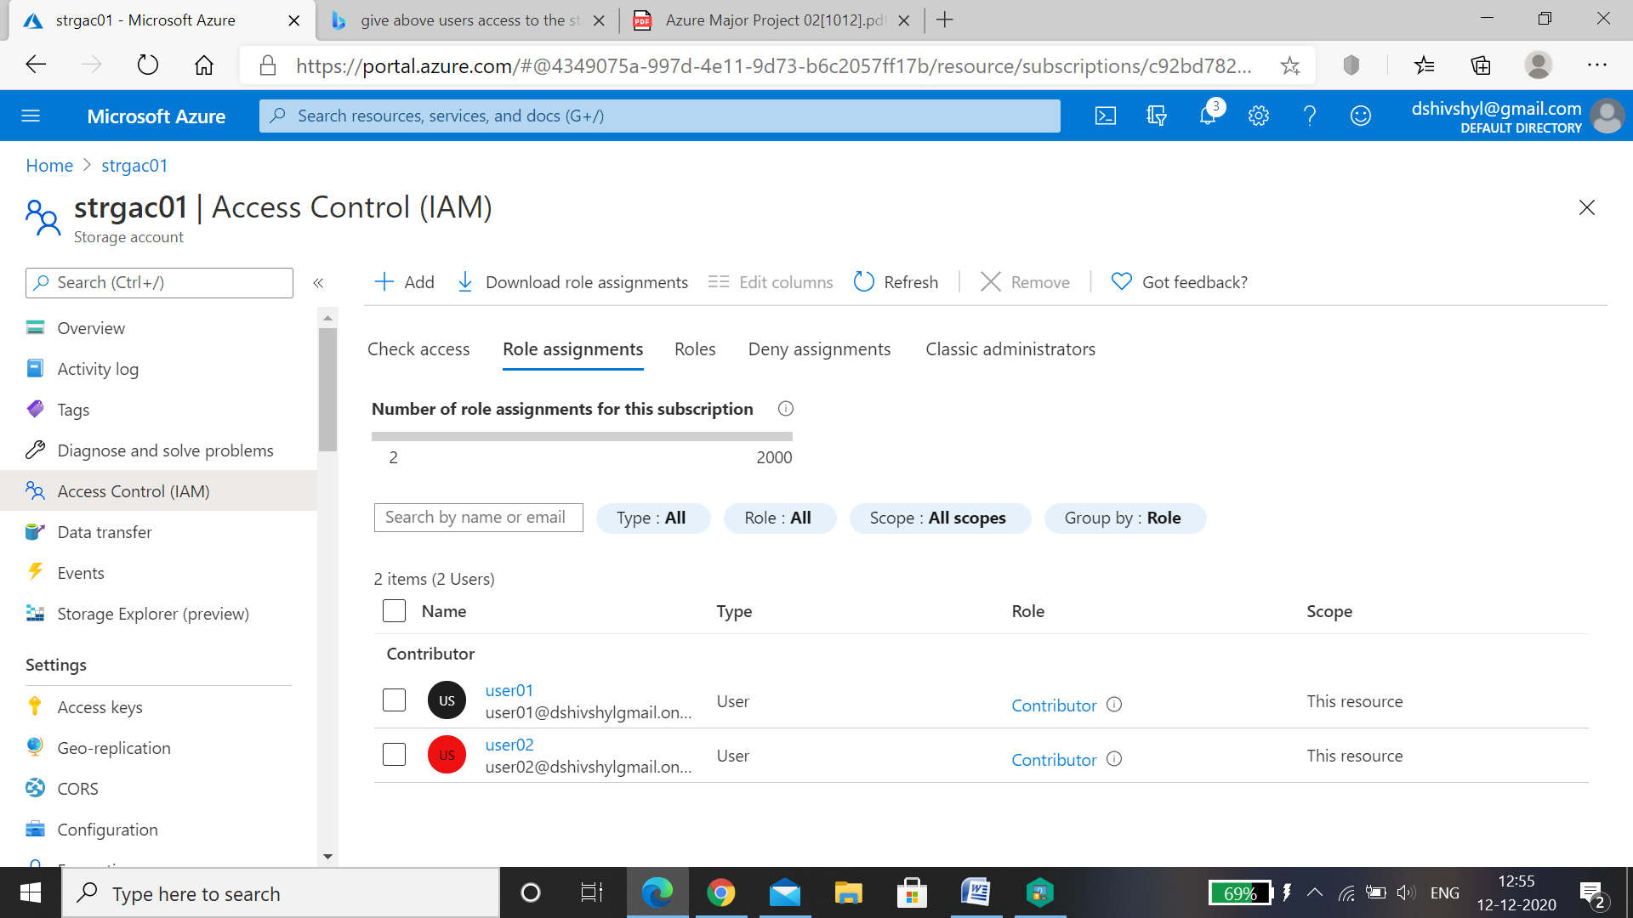

* Create an Azure Policy to only allow certain locations (Southeast Asia) for the resource group, try to create a resource in any other location and check the policy evaluation. (You can use any other region).

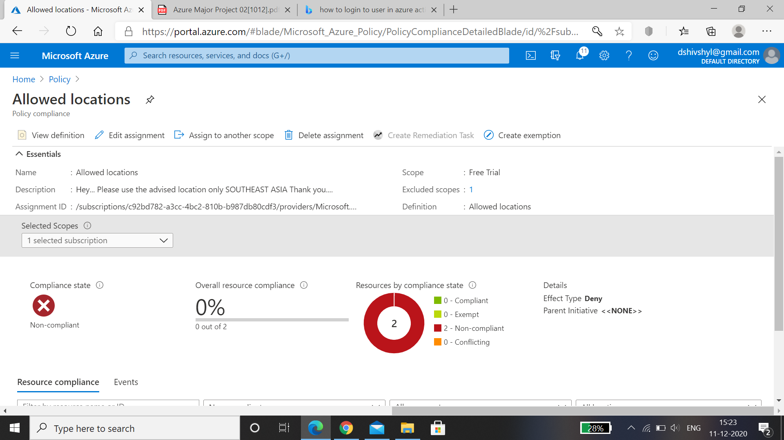

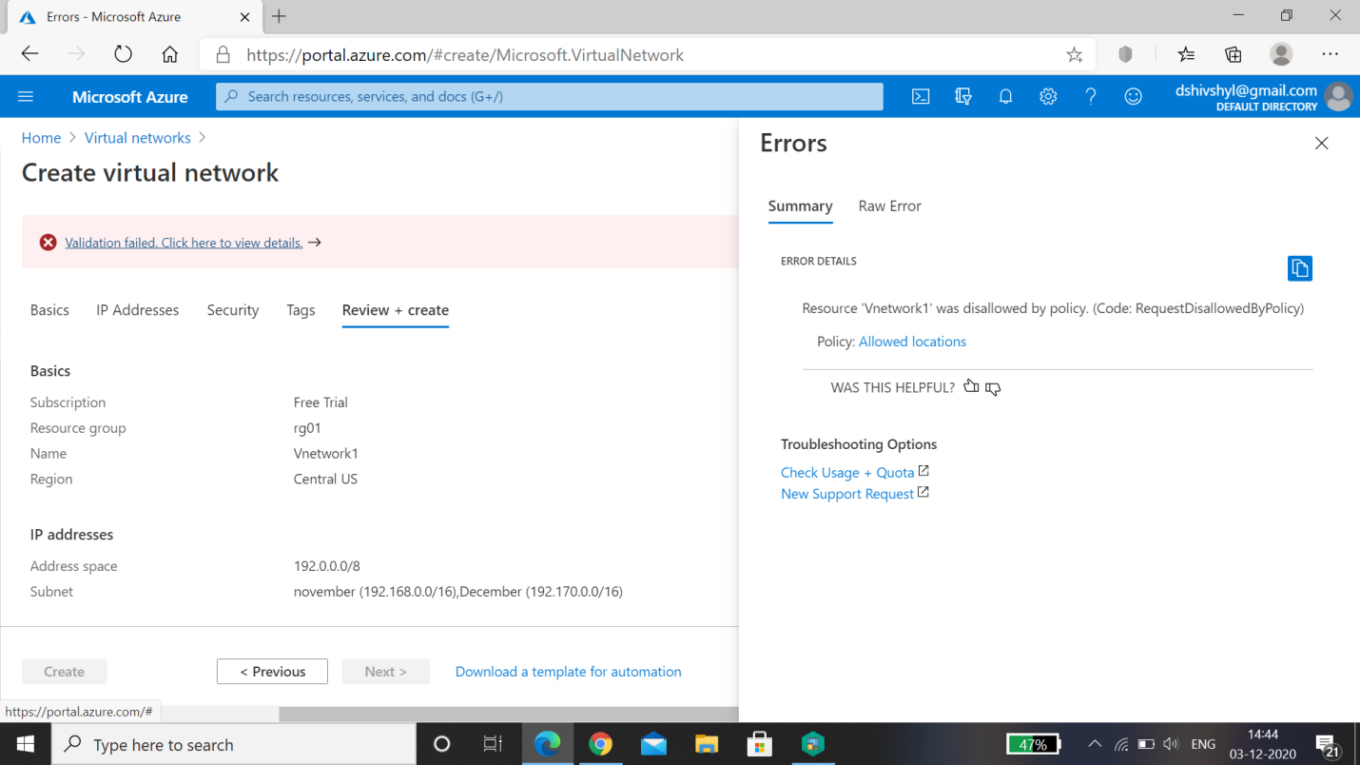

* Setup Ingress and Egress metrics for the both the above created Storage Account.
* Egress metrics of storage account 1

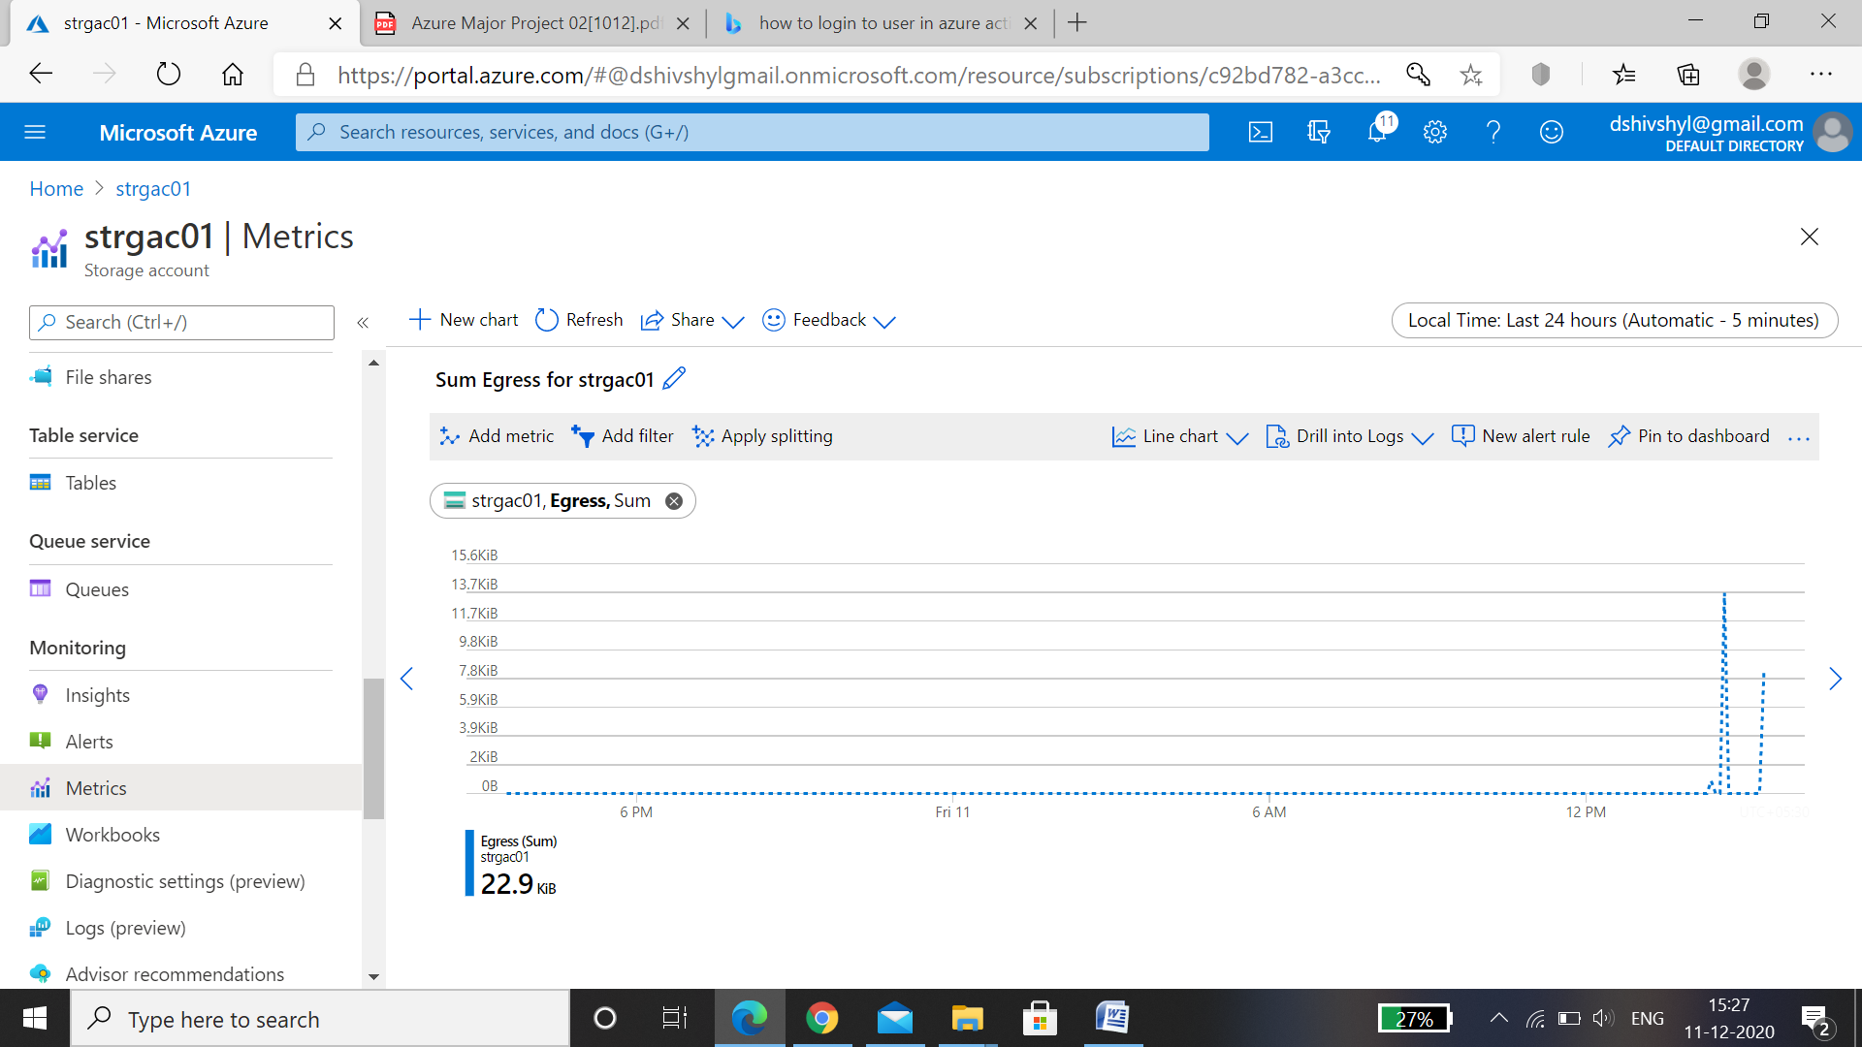

* Ingress metrics of storage account 1.

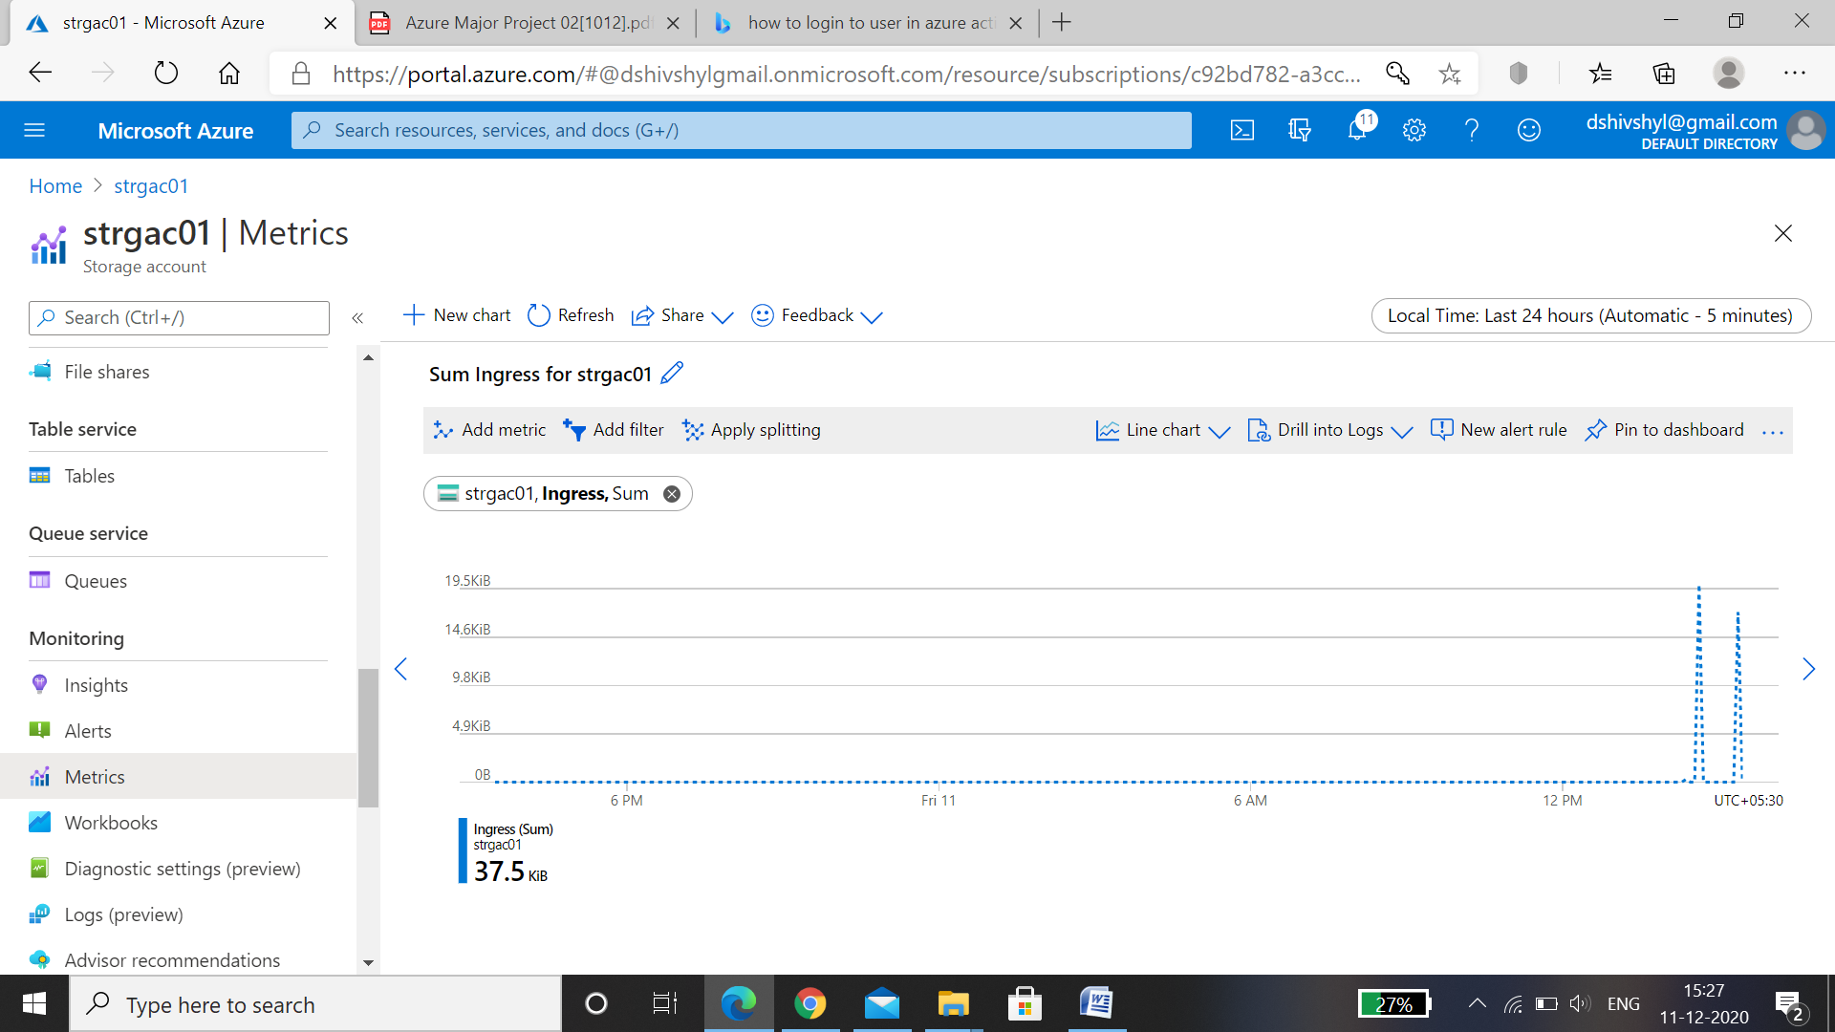

* Egress metrics of storage account 2.

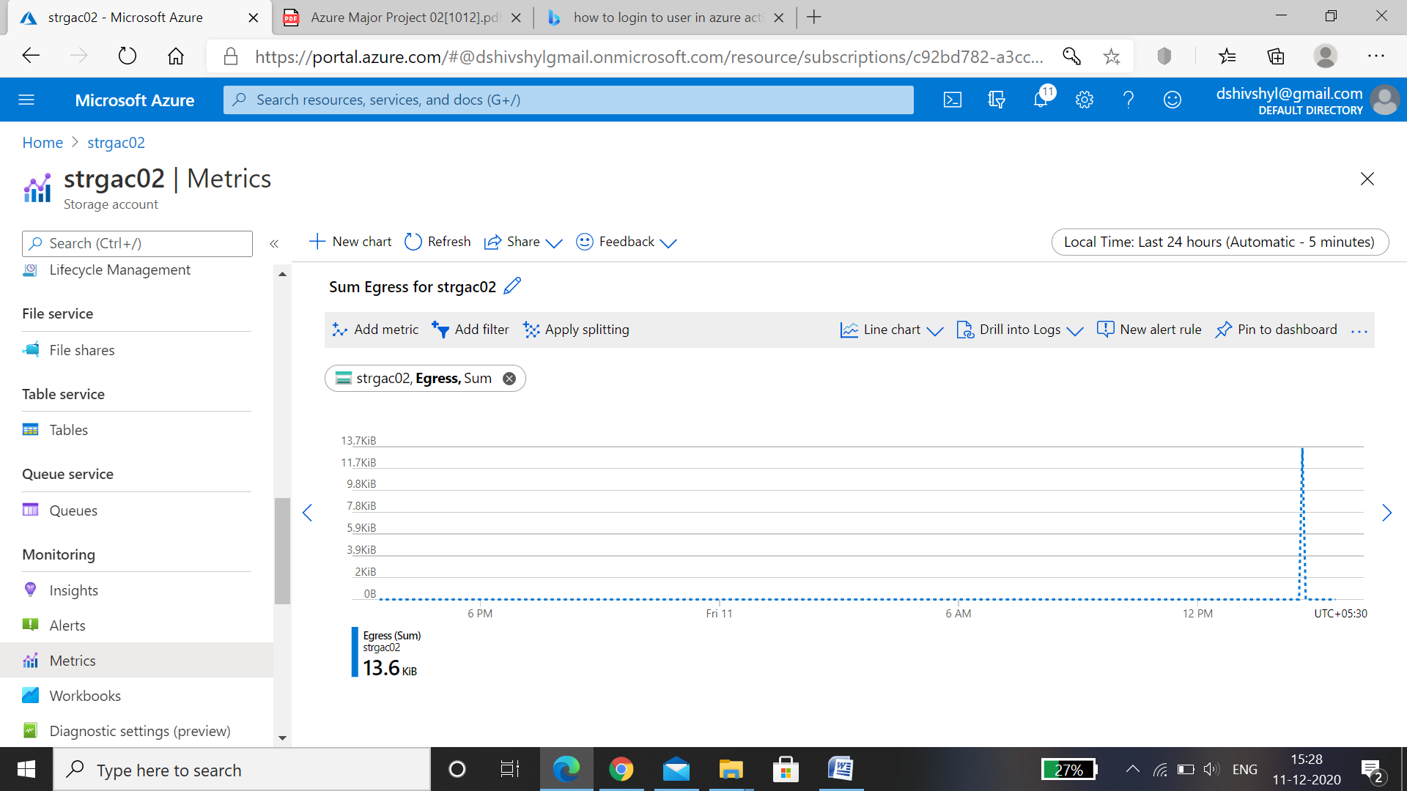

* Ingress metrics of storage account 2.

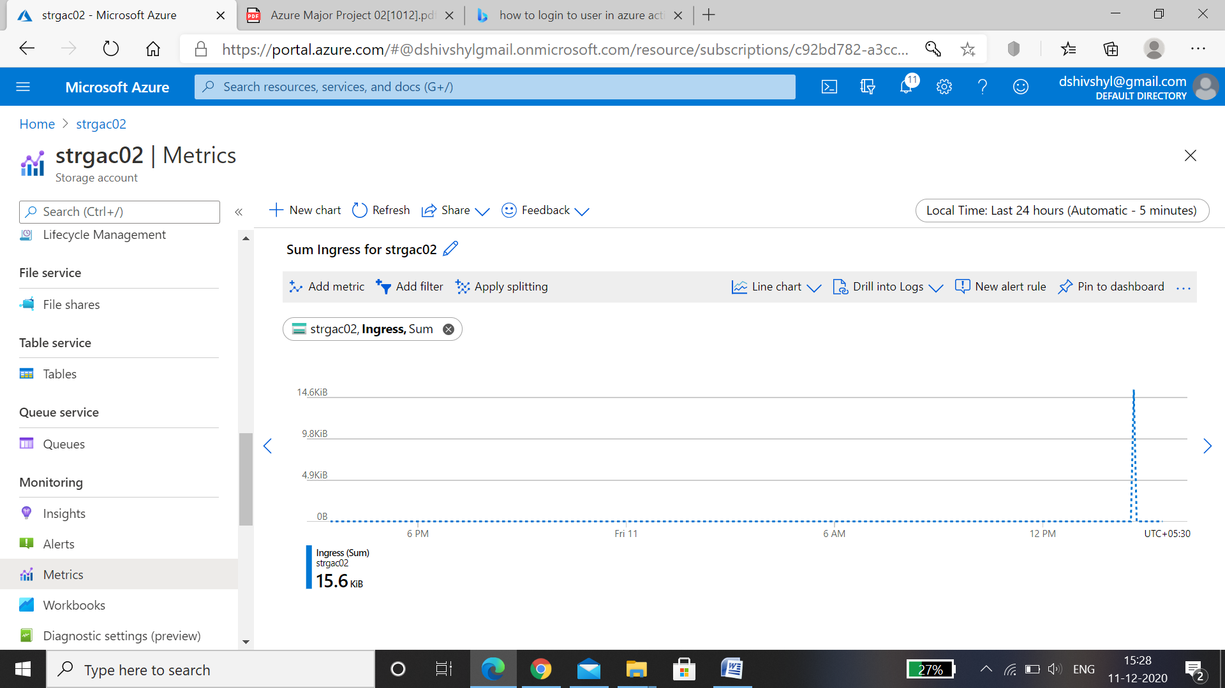

* Action group

Action Groups within Azure are a group of notification preferences and/or actions which are used by both Azure Monitor and service alerts.

* Action Group Verzactgrp is created and alert is sent to email id.

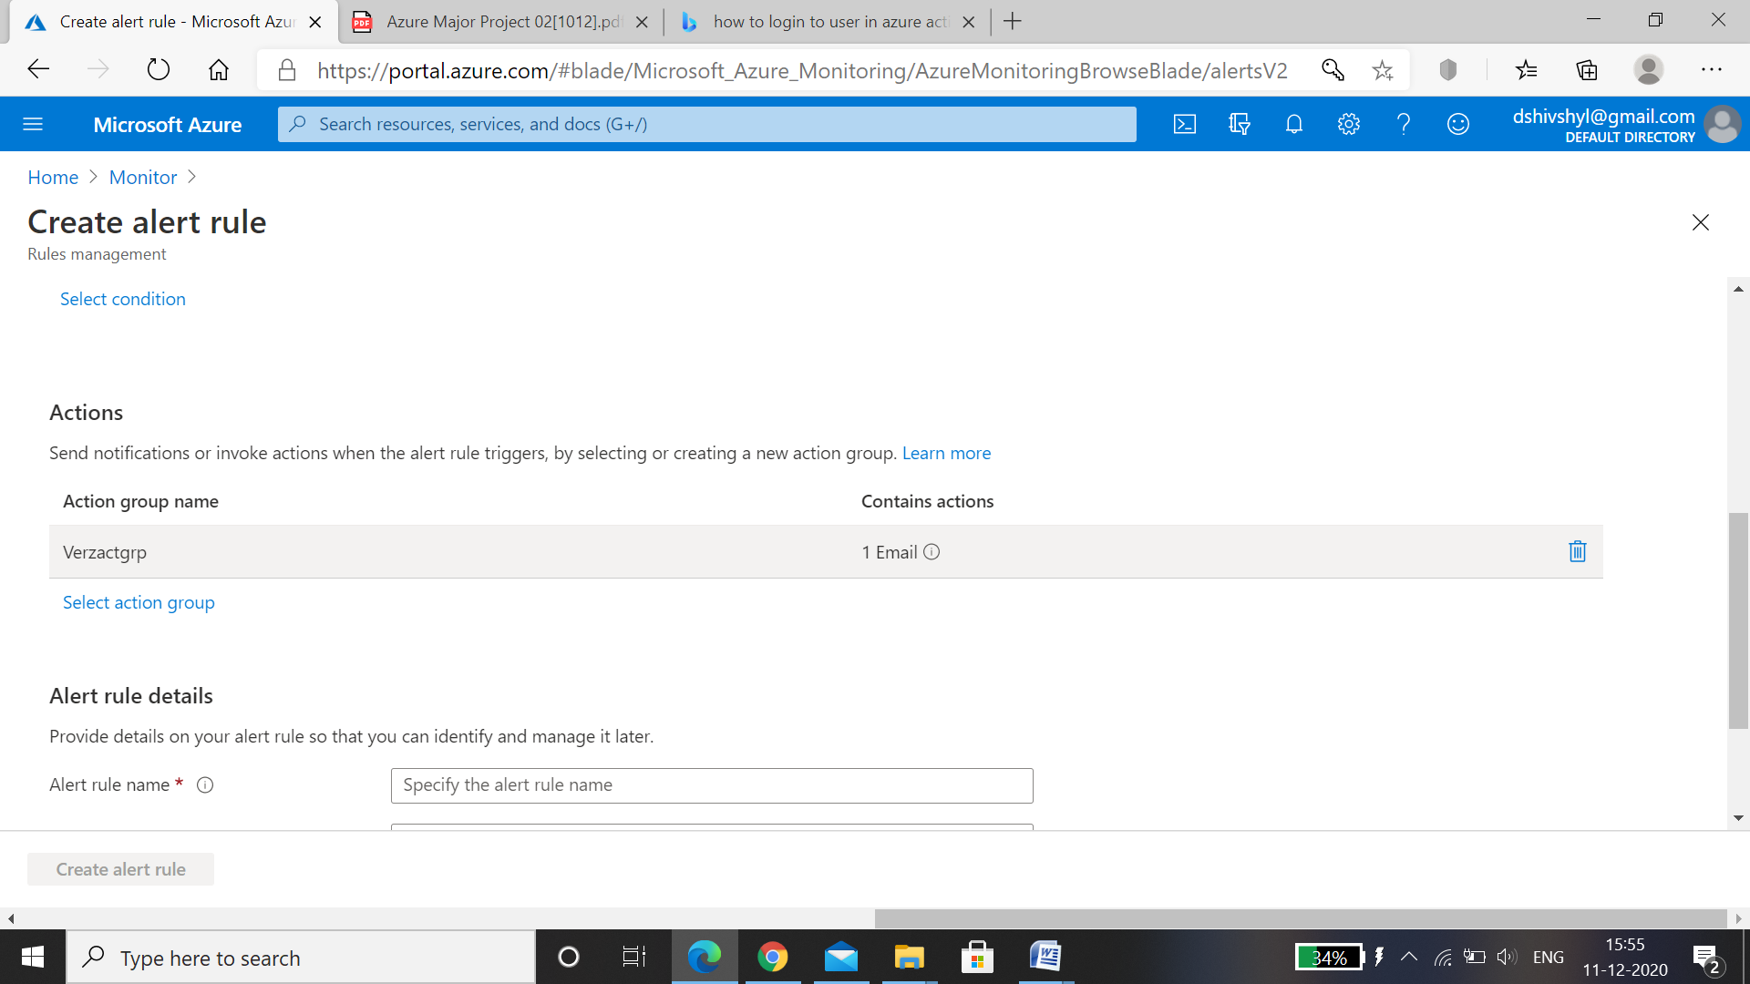

* Alert is received for the email id.

